SQL queries using SQL Server

(Due to constant “500 Internal error” displayed by Cognitive Class Labs, I used SQL server to produce this result)

# TASK 1: Display the names of the unique launch sites in the space mission

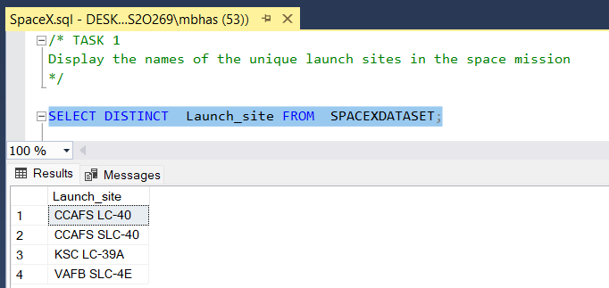

# TASK 2 – Display 5 records where launch sites begin with the string 'KSC'

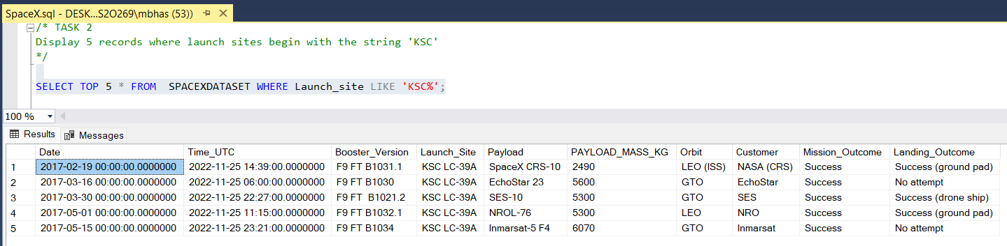

# TASK 3 - Display the total payload mass carried by boosters launched by NASA (CRS)

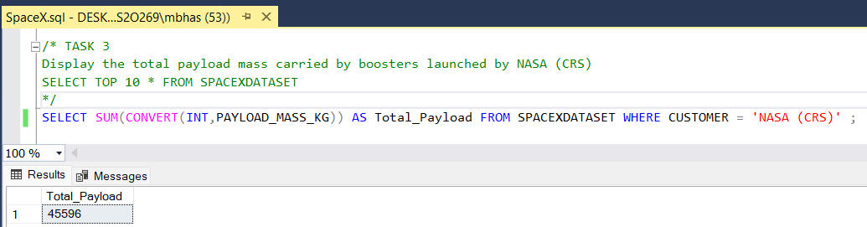

# TASK 4 - Display average payload mass carried by booster version F9 v1.1

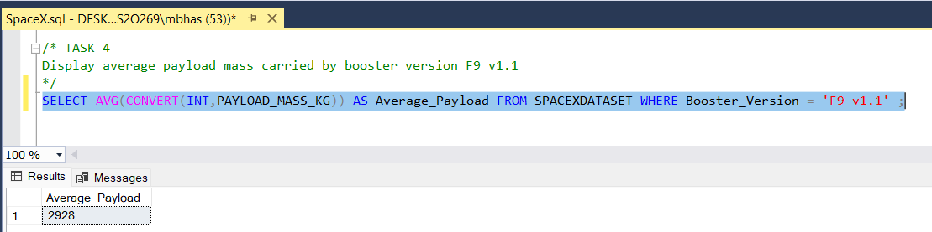

# Task 5 - List the date where the successful landing outcome in drone ship was achieved

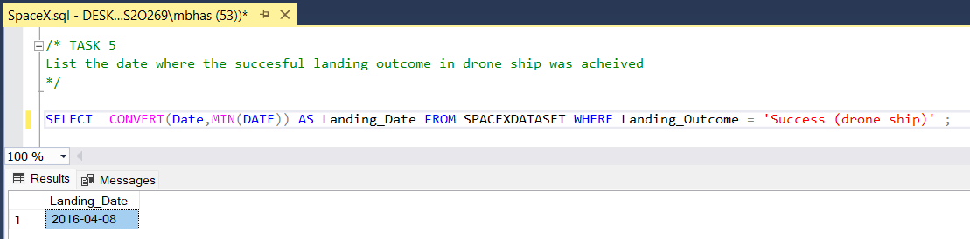

# TASK 6 - List the names of the boosters which have success in ground pad and have payload mass greater than 4000 but less than 6000

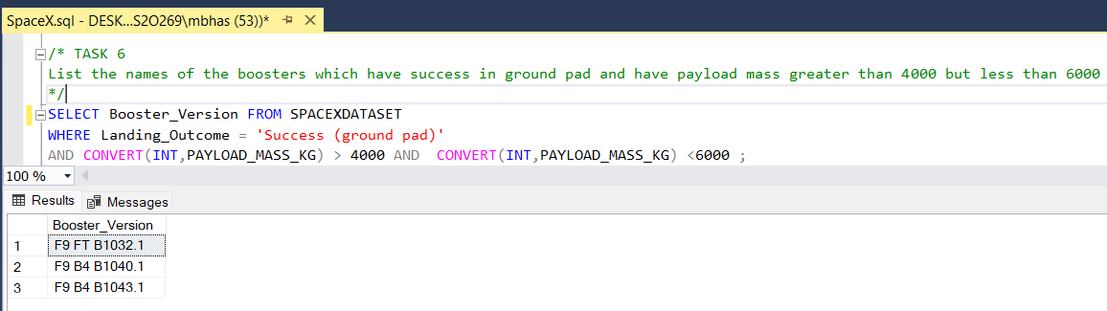

# TASK 7 - List the total number of successful and failure mission outcomes

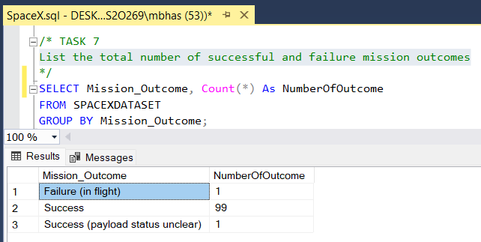

# TASK 8 - List the names of the booster_versions which have carried the maximum payload mass. Use a subquery

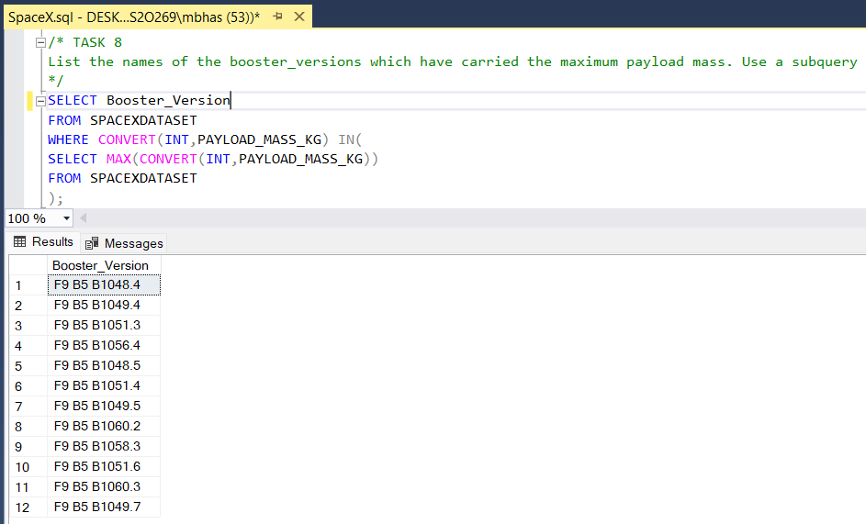

# TASK 9 - List the records which will display the month names, succesful landing_outcomes in ground pad ,booster versions, launch_site for the months in year 2017

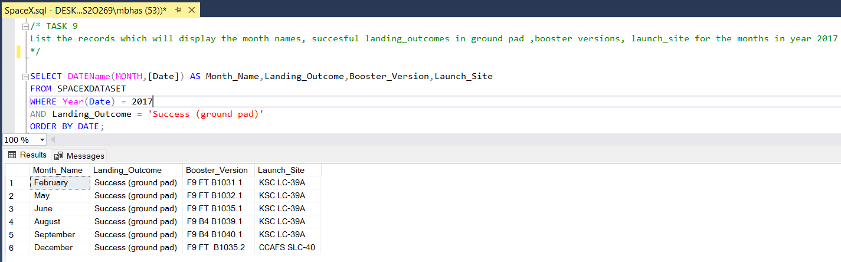

# TASK 10 - Rank the count of successful landing_outcomes between the date 04-06-2010 and 20-03-2017 in descending order.

